**OUTPUT SCREEN SHOTS WITH DESCRIPTION.**

**Home:** In our project, we are classifying the presence of Plant Leaf Diseases Classification, with the help of deep learning and machine learning.

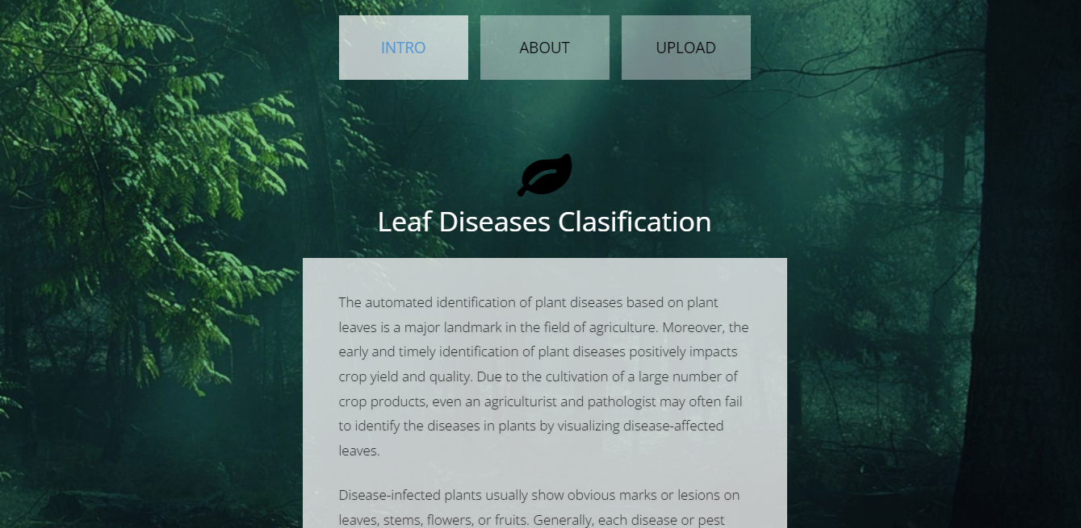

**Fig1:** Home

**About Project:** Here the user will get a breif idea about the project.

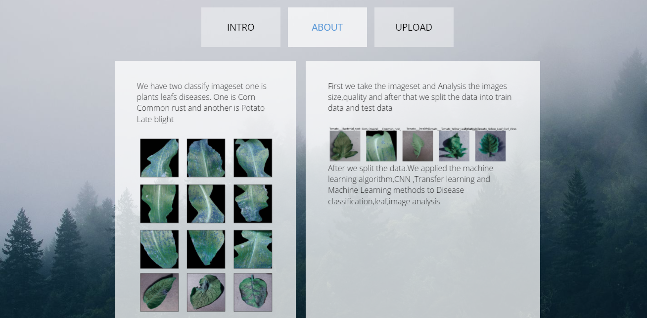

**Fig2**: About Project

**Upload Image:**

Here the images can be uploaded those which are to be classified.

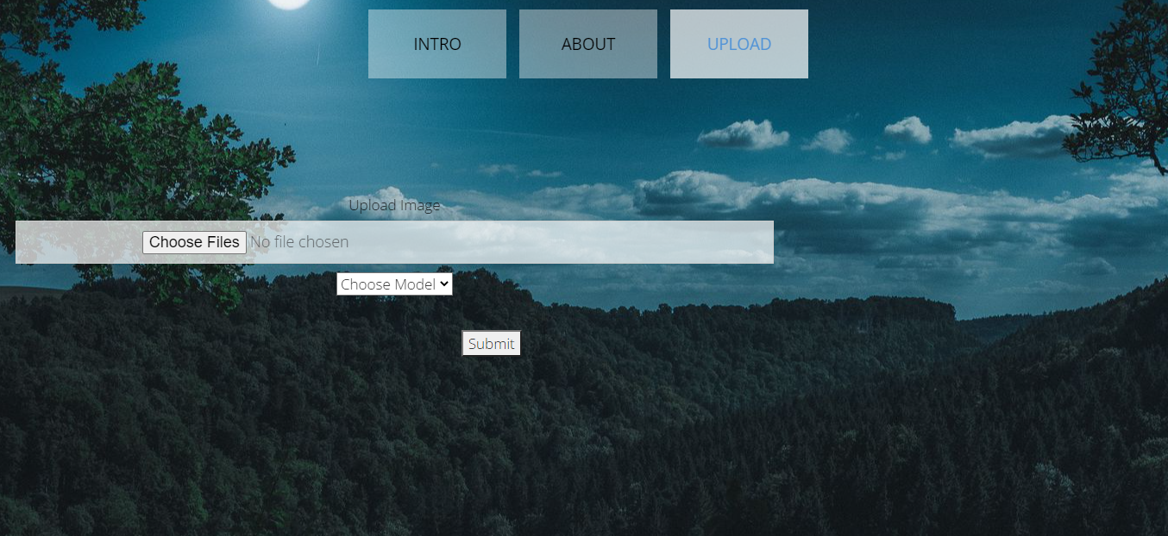

**Fig3**: Image Uploading

**Model choosing:**

Here the model can be selected, by which the image is to be classified.

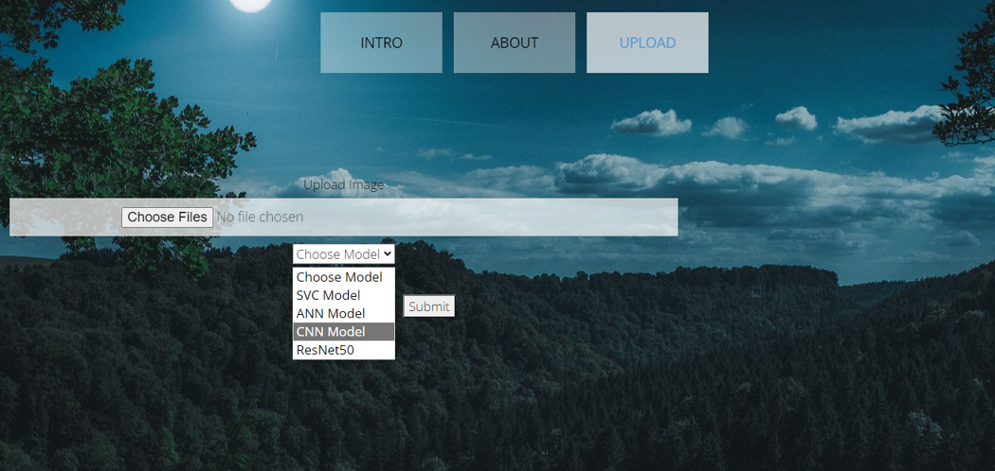

**Fig4:** Model choosing

**Classified output:**

The uploaded image is classified as the Corn_(maize)___Cercospora_leaf_spot Gray_leaf_spot.

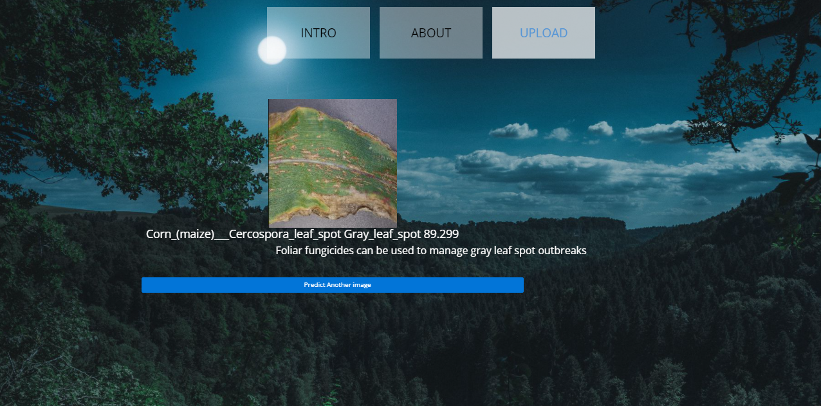

**Fig5**: Classified output

**Classified output:**

The uploaded image is classified as the Corn_(maize)___Common_rust_.

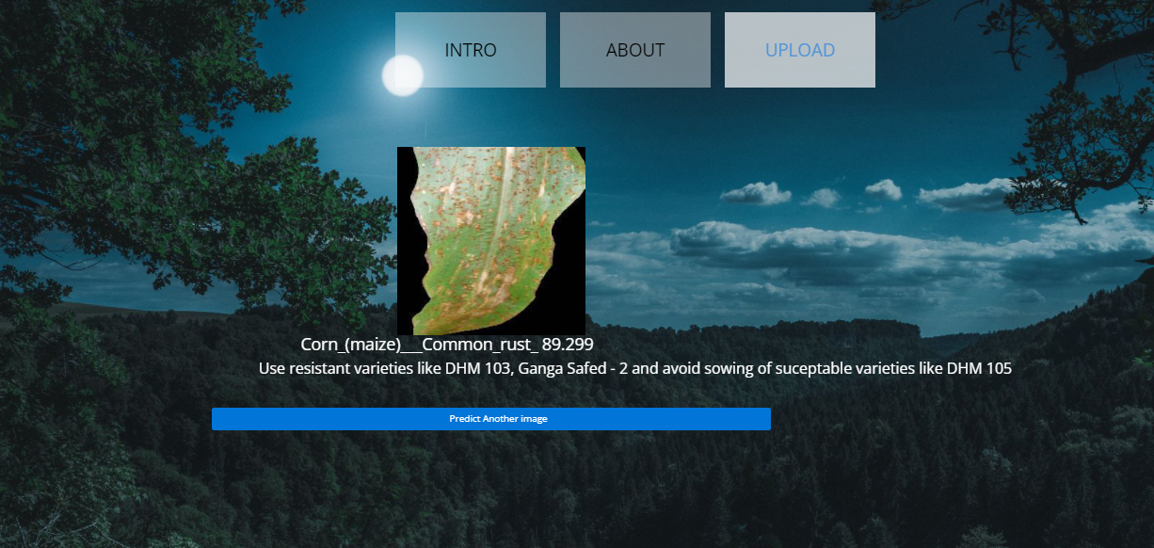

**Fig5**: Classified output

**Classified output:**

The uploaded image is classified as the Corn_(maize)___healthy.

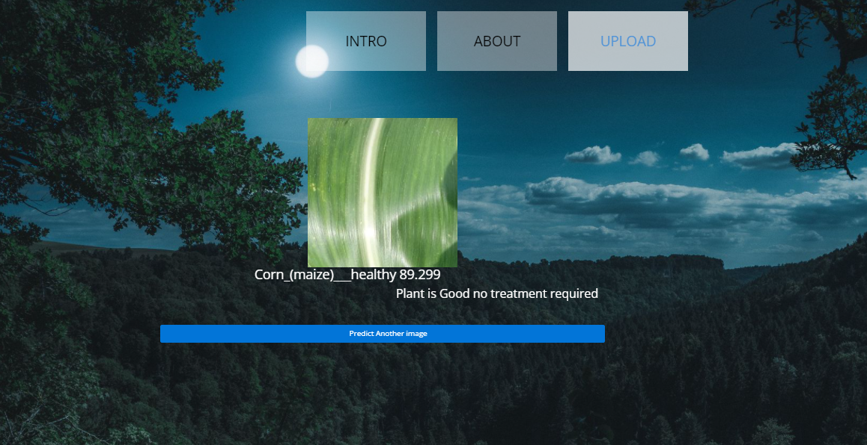

**Fig5**: Classified output

**Classified output:**

The uploaded image is classified as the Corn_(maize)___Northern_Leaf_Blight.

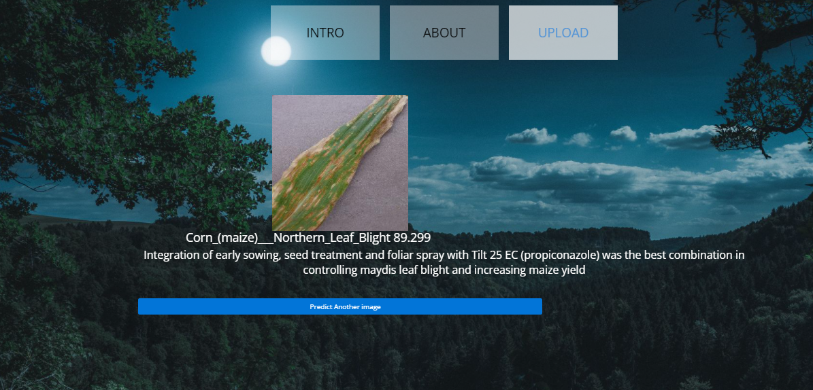

**Fig5**: Classified output

**Classified output:**

The uploaded image is classified as the Potato___Early_blight.

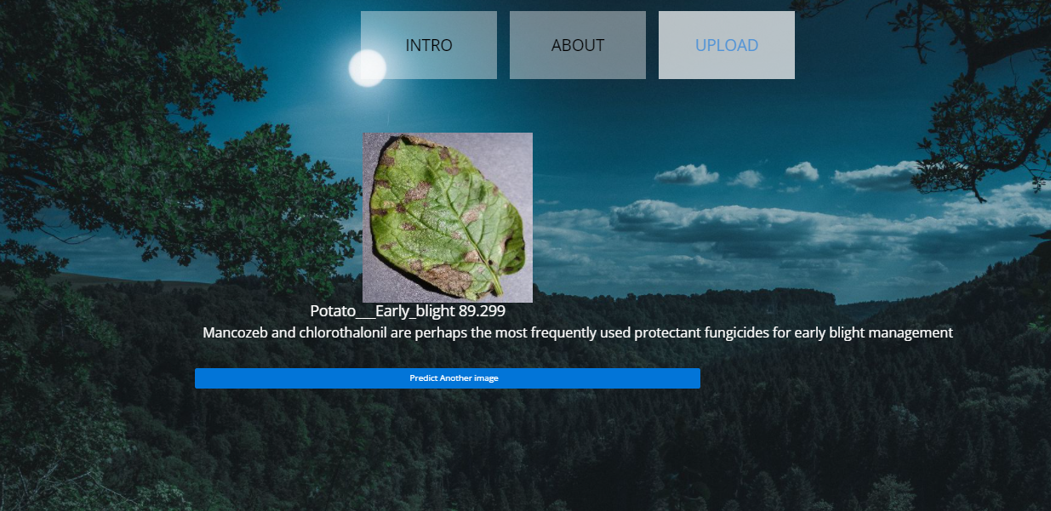

**Fig5**: Classified output

**Classified output:**

The uploaded image is classified as the Potato___healthy.

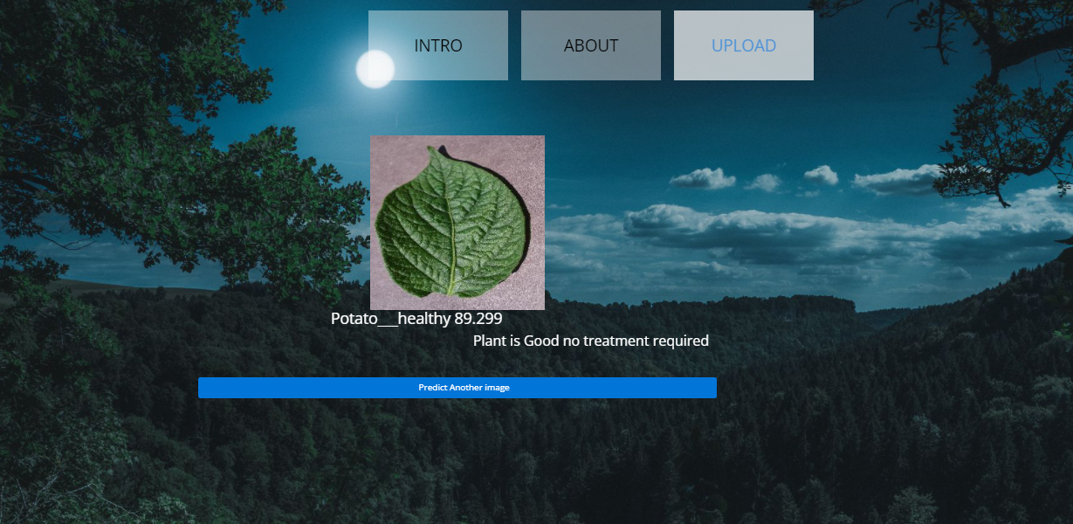

**Fig5**: Classified output

**Classified output:**

The uploaded image is classified as the Potato___Late_blight.

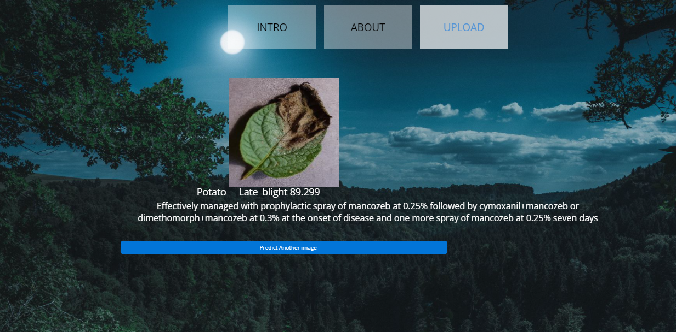

**Fig5**: Classified output

**Classified output:**

The uploaded image is classified as the Tomato___Bacterial_spot.

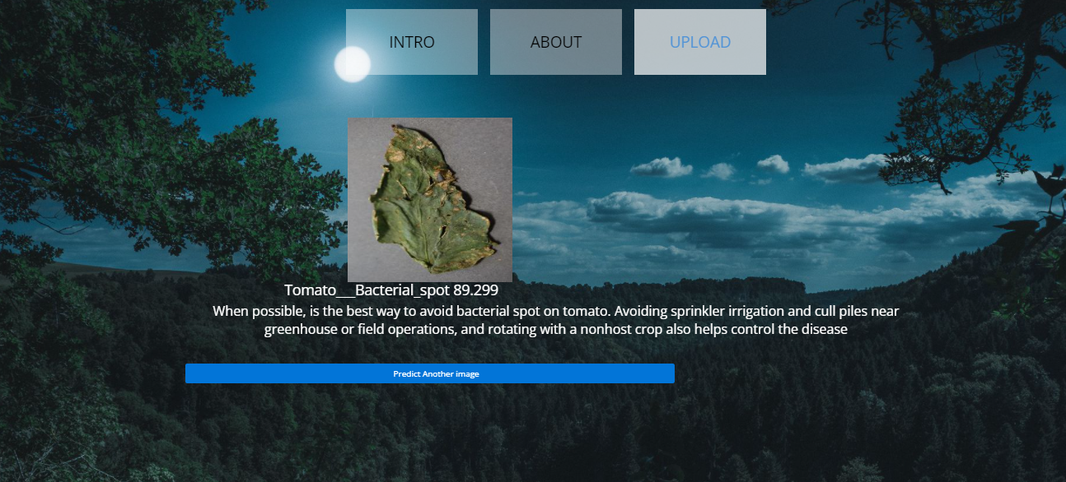

**Fig5**: Classified output

**Classified output:**

The uploaded image is classified as the Tomato___healthy.

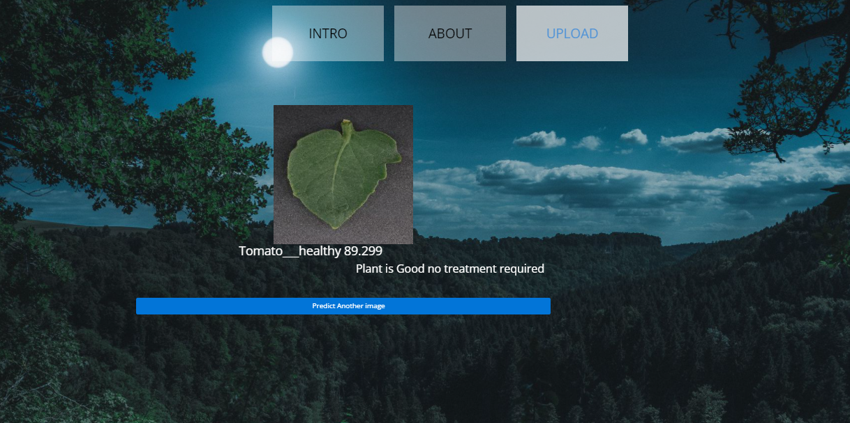

**Fig5**: Classified output

**Classified output:**

The uploaded image is classified as the Tomato___Late_blight.

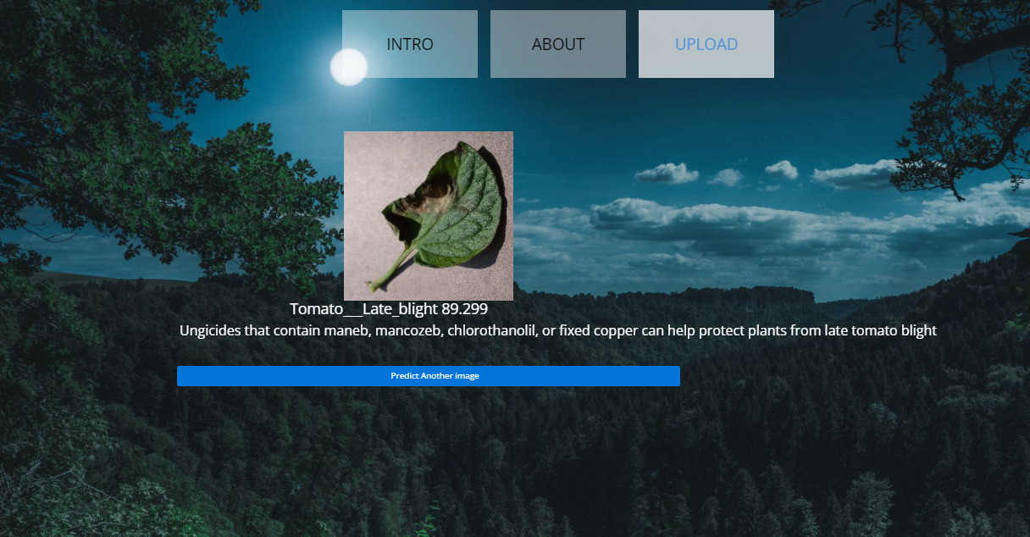

**Fig5**: Classified output

**Classified output:**

The uploaded image is classified as the Tomato___Tomato_Yellow_Leaf_Curl_Virus.

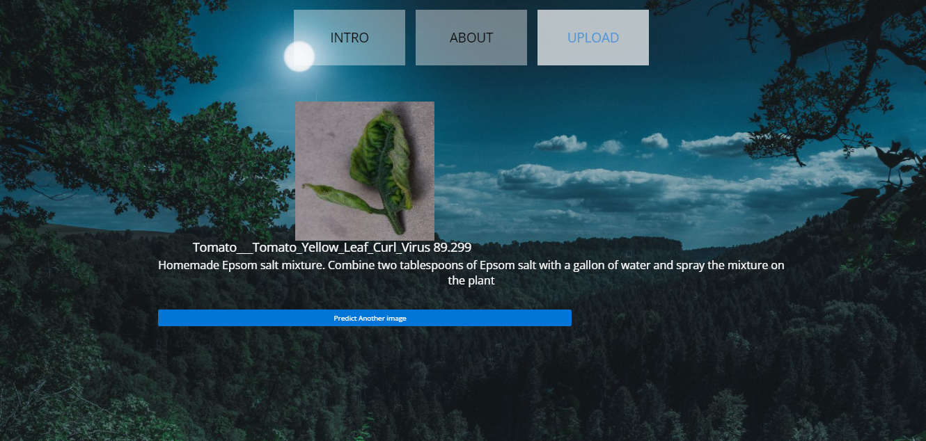

**Fig5**: Classified output